TEACHER:MWALE CHIPO
KENNETH KAUNDA SECONDARY SCHOOL DESIGN AND TECHNOLOGY DEPARTMENT
LESSON PLAN

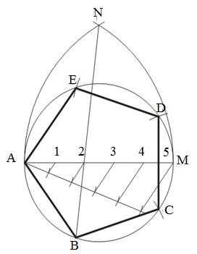
SUBJECT: DESIGN AND TECHNOLOGY CLASS:…… … DATE:……/……./20…. DURATION:…….
BOYS:…………………… GIRLS ………………………………………. TOTAL OF PUPILS… TOPIC: POLYGONS SUBTOPIC: POLYGONS LEARNING OUTCOMES LSBAT
- Define polygon
- Identify and explain type of polygons
- Construct the regular polygons in a circle
RATIONALE
Knowledge: Hexagon, Pentagon, octagon) given side, diameter, across the corner, across the flat.
Skills: Application of methods of polygons. Accurate Construction of regular and irregular polygons, Values: Awareness of methods of constructing polygons. Appreciation of polygons in design work TEACHING AIDS
PART | LESSON CONTENT |  |  | METHOD OLOGY | LEARNE R ACTIVIT Y
Introduction | - Recap on the previous lesson |  |  | Q/A | Provide answers
Developme nt | POLYGON  - A polygon is a plane figure bounded by more than four straight sides.  - Regular polygons with equal sides  - Irregular polygons with unequal sides  TYPES OF POLYGONS  - A Pentagon is a plane figure bounded by five sides.  - A Hexagon is a plane figure bounded by six sides.  - A Heptagon is a plane figure bounded by seven sides.  - An Octagon is a plane figure bounded by eight sides.  - A Nonagon is a plane figure bounded by nine sides.  - A Decagon is a plane figure bounded by ten sides  CONSTRUCTION OF POLYGON  To construct a regular polygon (pentagon) in a circle of diameter of 70mm
Developme nt |  | STEPS  - Draw the given circle and insert a diameter AM.  - Divide the diameter into the same number of divisions as the polygon has sides eg 5.  - With centre M draw an arc, radius MA. With centre A draw another arc of the same radius to intersect the first arc in N.  - Draw N2 and produce to intersect the circle in B  - AB is the first side of the polygon. Step out the other sides BC, CD, etc. | ABCDE is the required  PENTAGON POLYGON
Application | CLASS EXERCISE  - construct the following regular polygons in a circle of diameter of 70mm  - Hexagon Polygon  - Heptagon Polygon  - Pentagon Polygon |  |  | Questions And Answers | Provide answers
Conclusion | - Recap on the main steps and points |  |  | V/E

TEACHER:MWALE CHIPO
KENNETH KAUNDA SECONDARY SCHOOL DESIGN AND TECHNOLOGY DEPARTMENT
LESSON PLAN

SUBJECT: DESIGN AND TECHNOLOGY CLASS:…… … DATE:……/……./20…. DURATION:………….
BOYS:…………………… GIRLS ………………………………………. TOTAL OF PUPILS…
TOPIC: POLYGONS SUBTOPIC: POLYGONS
LEARNING OUTCOMES LSBAT
- To construct any given polygon, given the length of a side
RATIONALE
Knowledge: Construct regular polygons given side, diameter, across the corner, across the flat.
Skills: Application of methods of polygons. Accurate Construction of regular and irregular polygons, Values: Awareness of methods of constructing polygons. Appreciation of polygons in design work TEACHING AIDS
PART | LESSON CONTENT | METHODOLO GY | LEARNER ACTIVITY
introduction | - Recap on the previous lesson | Questions and answers | Provide answers
Developme nt | POLYGON  To construct any given heptagon polygon, given the length of a side. e.g the length of the polygon is 30mm  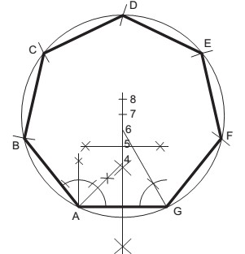  STEPS  - Draw a line GA equal in length to one of the sides.  - Bisect GA.  - From A construct an angle of 45 ° to intersect the bisector at point 4.  - 4. From G construct an angle of 60 ° to intersect the bisector at point 6.  - Bisect between points 4 and 6 to give point 5.  - Point 4 is the centre of a circle containing a square. Point 5 is the centre of a circle containing a pentagon. Point 6 is the centre of a circle containing a hexagon.  - With centre at point 7 draw a circle, radius 7 to A  - Step off the sides of the figure from A to B, B to C,  ABCDEFG is the required HEPTAGON
Application | CLASS EXERCISE  - Construct the following regular polygons. The length of the polygon is 30mm  - Hexagon Polygon  - Heptagon Polygon  - Pentagon Polygon | Questions And Answers | Provide answers
Conclusion | - Recap on the main steps and points | V/E

KENNETH KAUNDA SECONDARY SCHOOL DESIGN AND TECHNOLOGY DEPARTMENT
LESSON PLAN
TEACHER:MWALE CHIPO
SUBJECT: DESIGN AND TECHNOLOGY CLASS:…… … DATE:……/……./20…. DURATION:
BOYS:…………………… GIRLS ………………………………………. TOTAL OF PUPILS… TOPIC: POLYGONS SUBTOPIC: HEXAGON POLYGONS LEARNING OUTCOMES LSBAT
- To construct hexagon polygon using a 600 set square given Distance Across the Flat (diameter) (A/F)

RATIONALE
Knowledge: Construct regular hexagon, given side, diameter, across the flat.
Skills: Application of methods of polygons. Accurate Construction of regular and irregular polygons, Values: Awareness of methods of constructing polygons. Appreciation of polygons in design work TEACHING AIDS
PART | LESSON CONTENT | METHODOL OGY | LEARNER ACTIVITY
introduction | - Recap on the previous lesson | Questions and answers | Provide answers
Developme nt | POLYGON DISTANCE ACROSS THE FLAT  To construct hexagon polygon using a 600 set square given  Distance Across the Flat (diameter) (A/F)  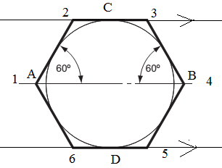  STEPS  - Draw a line and on it mark AB = 60mm to represent A/F  - Mark off mid-point and construct a circle  - From C and D draw parallel lines to distance A/F=AB.  - Use 600 Set Square to complete the required regular hexagon
Application | CLASS EXERCISE  Construct the regular hexagon given that: A/F50mm | Questions And Answers | Provide answers
Conclusion | - Recap on the main steps and points | V/E

TEACHER:MWALE CHIPO
KENNETH KAUNDA SECONDARY SCHOOL DESIGN AND TECHNOLOGY DEPARTMENT
LESSON PLAN

SUBJECT: DESIGN AND TECHNOLOGY CLASS:…… DATE:……/……./20…. DURATION:…
BOYS:…………………… GIRLS ………………………………………. TOTAL OF PUPILS… TOPIC: POLYGONS SUBTOPIC: HEXAGON POLYGONS LEARNING OUTCOMES LSBAT
- To construct hexagon polygon in circle when given Distance Across the Corner (diameter) (A/C)

RATIONALE
Knowledge: Construct regular hexagon, given side, diameter, across the corner,
Skills: Application of methods of polygons. Accurate Construction of regular and irregular polygons, Values: Awareness of methods of constructing polygons. Appreciation of polygons in design work TEACHING AIDS
PART | LESSON CONTENT | METHODOL OGY | LEARNER ACTIVITY
introduction | - Recap on the previous lesson | Questions and answers | Provide answers
Developme nt | POLYGON DISTANCE ACROSS THE CORNER  To construct hexagon polygon in circle when given Distance Across the Corner (diameter) (A/C)  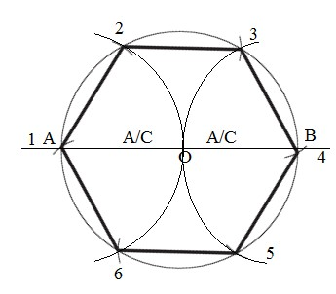  STEPS  - Draw a line and on it mark AB = 70mm to represent A/C  - Mark off mid-point and construct a circle  - Using the same radius stand at point A and B and construct two arcs below and two arcs above the given circumference.
Application | CLASS EXERCISE  Construct the regular hexagon given that: A/C65mm | Questions And Answers | Provide answers
Conclusion | - Recap on the main steps and points | V/E

KENNETH KAUNDA SECONDARY SCHOOL DESIGN AND TECHNOLOGY DEPARTMENT
LESSON PLAN
TEACHER:MWALE CHIPO
SUBJECT: DESIGN AND TECHNOLOGY CLASS:…… … DATE:……/……./20…. DURATION:………….

BOYS:…………………… GIRLS ……… TOTAL OF PUPILS…
TOPIC: POLYGONS SUBTOPIC: OCTAGON POLYGONS

LEARNING OUTCOMES LSBAT
- To construct a regular octagon in a square.

RATIONALE
Knowledge: Construction regular octagon
Skills: Application of methods of polygons. Accurate Construction of regular and irregular polygons, Values: Awareness of methods of constructing polygons. Appreciation of polygons in design work TEACHING AIDS
……………………………………………………………………………………………………………………………………………

PART | LESSON CONTENT | METHODOL OGY | LEARNER ACTIVITY
introduction | - Recap on the previous lesson | Questions and answers | Provide answers
Developme nt | POLYGON  To construct a regular octagon in a square.  Construct a regular octagon, given that the square is 70 mm  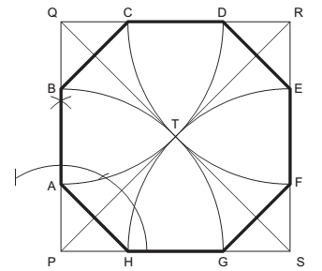  STEPS  - Construct a square PQRS, length of side equal to the diameter.  - Draw the diagonals SQ and PR to intersect in T.  - With centres P, Q, R and S draw four arcs, radius PT ( = QT= RT= ST) to cut the square in A, B, C, D, E, F, G and H.
Application | CLASS EXERCISE  1. Construct a regular octagon, given that the square is 70 mm | Questions And Answers | Provide answers
Conclusion | - Recap on the main steps and points | V/E

TEACHER:MWALE CHIPO

KENNETH KAUNDA SECONDARY SCHOOL DESIGN AND TECHNOLOGY DEPARTMENT
LESSON PLAN

SUBJECT: DESIGN AND TECHNOLOGY CLASS:…… … DATE:……/……./20…. DURATION:………….
BOYS:…………………… GIRLS …………… TOTAL OF PUPILS… TOPIC: POLYGONS SUBTOPIC: IRREGULAR POLYGONS LEARNING OUTCOMES LSBAT
- To construct irregular polygons from the given data.

RATIONALE
Knowledge: Construct irregular polygons (hexagon, Pentagon, octagon)
Skills: Application of methods of polygons. Accurate Construction of regular and irregular polygons, Values: Awareness of methods of constructing polygons. Appreciation of polygons in design work TEACHING AIDS
……………………………………………………………………………………………………………………………………………

PART | LESSON CONTENT | METHODOL OGY | LEARNER ACTIVITY
introduction | - Recap on the previous lesson | Questions and answers | Provide answers
Developme nt | IRREGULAR POLYGON  Construct an irregular pentagon given that AB=30, BAE=1200, ABC= 1050, BC= 36, AE=40, ED=66 and DC=67  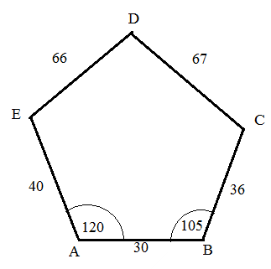  STEPS  - Draw AB= 30mm  - Construct angles 1200 at point A and 1050 at B  - Measure AE =40mm and BC= 36mm.
Application | CLASS EXERCISE  Construct an irregular pentagon given that AB=30, BAE=1200, ABC= 1050, BC= 36, AE=40, ED=66 and DC=67 | Questions And Answers | Provide answers
Conclusion | - Recap on the main steps and points | V/E

HOME WORK
13F

TEACHER: ………………............................

CLASS:……… DATE GIVEN:…………………............. TOPIC: POLYGONS ANSWER ALL QUESTIONS
- Construct a regular hexagon, 45 mm side.
- Construct a regular hexagon if the diameter is 75 mm.
- Construct a regular hexagon within an 80 mm diameter circle. The corners of the hexagon must all lie on the circumference of the circle.
- Construct a square, side 100 mm. Within the square, construct a regular octagon. Four alternate sides of the octagon must lie on the sides of the square.
- Construct the following regular polygons:
  - a pentagon, side 65 mm;
  - a heptagon, side 55 mm;
  - a nonagon, side 45 mm;
  - a decagon, side 35 mm.
- Construct a regular pentagon, diameter 82 mm.
- Construct a regular heptagon within a circle, radius 60 mm. The corners of the heptagon must lie on the circumference of the circle

